Customer Service Assistant – Temporary
Up to £26,422 per annum (pro rata for part time)
Job Title: Customer Services Assistant

Place of work: The Group’s head office is located in High Street, Swansea and this would be your base.

This role requires the post holders to work a mix of hybrid working. In the office for a minimum of 3 days per week for full time staff (this is prorated for part time staff). This is regularly reviewed to ensure it meets the business needs, there is also the requirement to attend in person meetings and training as needed.

From January 2nd 2025 Coastal and RHA will be Beacon Cymru Group Ltd. You can find out more about this merger at https://www.coastalha.co.uk/merger/

Our new organisation name, beacon, was chosen as beacons have illuminated human history as symbols of hope and guidance. They’ve been used by many cultures to communicate across distances as their glow unites people and provides direction. Whether on hills, mountains or coastal cliffs, a beacons enduring presence reflects our shared understanding and our shared purpose

Accountable to: Senior Customer Service Assistant

Hours of work: We are looking to recruit various contracts up to a maximum of 35 hours per week on a temporary basis. The Customer Service Team currently are available Monday to Thursday 8.30am to 5.00.pm and Friday 8.30am to 4.30pm

As part of your application please indicate the minimum and maximum number of hours per week you would be interested in.

Our application process

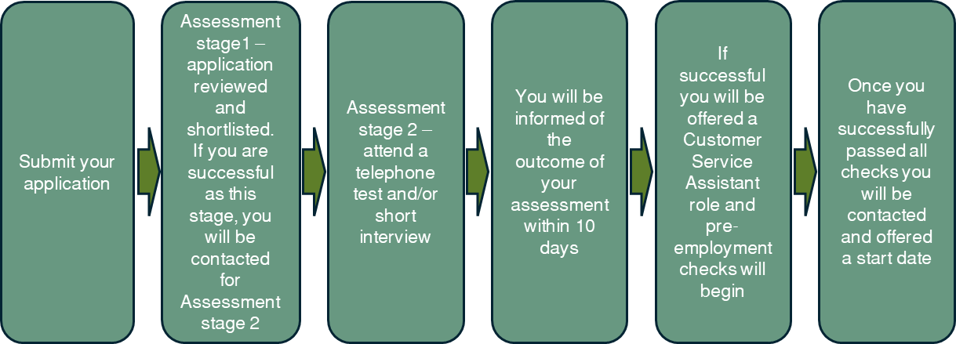

Salary: Up to £26,422 per annum (pro rata for part time)

About Coastal

At Coastal we’re a team in the truest sense of the word. We value relationships highly, so we invest in them daily. As a result, our workplace culture is open, trusting and respectful. It’s also safe, which we think is pretty critical to encouraging new ideas and approaches.

We employ almost 300 people across south west Wales and we trust every single one of them to know, and do, their work in the way that gets the best results for residents, the local community and the planet.

Coastal’s vision is to provide homes and services that enable our tenants to thrive and the communities we serve to prosper, supported by growing our social business and extending the reach of our homes and services.

This is supported by our digital vision, which is to use technology to support and enable our aims and priorities, and to enhance our services, communication and interaction with customers and businesses across the communities in which we work. In doing this we will endeavour to create opportunities through our digital strategy for customer focus, innovation and sustainability.

Vision and Values

Vision
Providing homes and services that enable our tenants to thrive and the communities we serve to prosper.

Values
- Trust – we trust our staff to get the job done
- Respect – we respect our tenants and our staff and have a no blame culture
- Innovation – we try new things so we can do things better
- Learning and growing – we think about what we do and learn from it
  - High Standards – we are proud of what we do and aim always to deliver the right service at the right time

Job Summary

Coastal has a long history of working in a systems thinking way and we continue to be committed to it. This means we design how we work to deliver maximum value (as defined by people we serve), we seek to remove waste and bureaucracy and we use method and measures to study ‘how the work works’.

The customer service team are the first point of contact for lettings, tenancy management and general enquires for our residents. This could be by phone, email, webchat, letter or in person.

Purpose of Role

As a customer services assistant, the focus is on;

- Helping the residents, applicants and other customers who contact us, resolving as many queries at the first point of contact as possible, signing posting as appropriate or arranging for the right colleague to contact them

- Working collaboratively with colleagues both in customer services and the wider teams

- Ensuring that decisions are based on knowledge and data, not opinions or assumptions

- Ensuring that the quality of service delivered is consistent and of a high standard

General Responsibilities

- Answering internal and external customer queries makes up a large part of your role, keeping you in regular contact with them face to face, over the phone, through social media, by email, letter, live chat or social media.

- Ensure an excellent standard of customer service is provided to all applicants, residents and other customers including maintaining accurate and up to date records as specified by the Group.

- Creating and managing mail merge (bulk) and ad hoc communications either via CX, Microsoft Office or other appropriate systems.

- Preserve systems thinking as the method for improvement, leading by example:

  - Performance is driven by the systems we design and the thinking that underpins these
  - Purpose, measures and method need to be clearly defined
  - Understanding demand, identifying value and analysing the flow of work are central to the method
  - We use the cycle of ‘check, plan, do’ when studying a system and experimenting with new ways of working

- Embody the organisation’s values and model appropriate behaviours at all times and in all areas of accountability.

- Using restorative and asset based approaches and enable a culture of high support/high challenge across all activities, duties and functions.

- Be able to effectively investigate and respond to informal complaints.

- Treat colleagues, clients and stakeholders in a fair, non-discriminatory way

Workplace Responsibilities
- Training/Development
Have an awareness of own personal development needs. To actively seek to keep up to date with any changes to internal policies and an awareness of any changes to legislation or regulations.

- Health & Safety
To comply with Health and Safety regulations and the Group’s working procedures

- Equal Opportunities
To treat colleagues and clients in a fair and non-discriminatory way

- Any Other Duties
To carry out any other duties reasonably requested by the Group.

This is not exhaustive and may change to meet the needs of the Group.

Essential | Desirable | Customer Services Assistant  Person Specification
Qualifications & Experience
ü |  | A relevant customer services qualification or equivalent experience
ü |  | Excellent IT skills and an aptitude for digital technology, including using Microsoft Office applications and social media
ü |  | Excellent communication skills including the ability to listen, mediate and deal with challenging conversations
 | ü | Willing to undertake any training that will develop the role and themselves
Skills and Knowledge
ü |  | Knowledge and understanding of customer service and the importance of providing outstanding customer service
 | ü | Knowledge of the Social Housing sector
ü |  | Able to build, maintain and repair good working relationships
ü |  | Flexible, adaptable and a good listener
ü |  | Team player with an open and honest manner
ü |  | Able to work independently and on own initiative
 | ü | Ability to communicate in Welsh
ü |  | Diplomatic and able to handle matters sensitively
ü |  | Excellent interpersonal skills, with the ability to communicate clearly and with influence, in writing, verbally and numerically
ü |  | Able to work accurately and efficiently
Personal Qualities
ü |  | Able to recognise and adhere to professional boundaries
ü |  | Resilient and able to deal with challenging situations
ü |  | Self aware and committed to own development
ü |  | Ability to cope in a fast-paced working environment and multitask
ü |  | A receptive and adaptable approach to change and open to new ways of doing things
General
ü |  | Committed to attending some meetings or events as required even if outside of normal working pattern
ü |  | Willing to contribute to and be actively involved in engagement activities and events
 | ü | Full driving license and access to a car; or able to demonstrate ability to be fully mobile in the role

